Olaus Rudbeck Honored at Hortonville High School

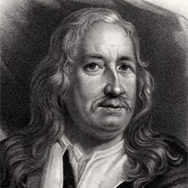
Today at Hortonville High School, we honor Olaus Rudbeck, Sr. (1630-1702), from Sweden, who has made an important contribution in the field of human anatomy by discovering the lymphatic system in the human body at Uppsala University of Sweden in the year 1652. However, at about the same time, the Danish scientist Thomas Bartholin also published a similar discovery, and there is disagreement in which man discovered the lymphatic system first.
The lymphatic system, which is part of the body’s circulatory system, collects and recycles fluids leaked from the cardiovascular system and is involved in fighting infection. This discovery of the lymphatic system is important because it relates to maintaining homeostasis in the body. Homeostasis refers to the maintenance of a stable internal condition in spite of changes in the external environment.
Olaus Rudbeck, Sr.
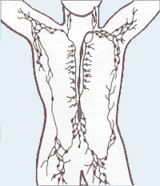
Olaus Rudbeck was also known for his three books, which attempted to prove that Sweden was the location of the Lost City of Atlantis.
Olaus Rudbeck was also known for his plant collection. In honor of Olaus Rudbeck Sr, and his son, Olaus Rudbeck, Jr., the plant genus containing the commonly named Black-Eyed Susans became known as the genus Rubeckia. This genus was named by Carolus Linnaeus, who is known for his system of naming organisms. Linnaeus was a student of Olaus Rudbeck, Jr.
Lymphatic System Diagram

Rudbeckia hirta, Black-Eyed Susan

